Web Dev Final Report – Book Haven Bookstore

Name: Elizaveta Skomorokhova
Date: 20.05.2026
Final Program
View the website here: https://elizaveta-sk.github.io/Book_Haven_Bookstore/
Code here: https://github.com/elizaveta-sk/Book_Haven_Bookstore.git

Introduction
Client name: Book Haven Bookstore
Book Haven Bookstore is a local bookstore dedicated to supporting literary exploration and fostering a strong community of readers. It offers a wide range of books, magazines, journals, and office supplies for students, avid readers, and knowledge seekers.
This report presents the development and implementation of the Book Haven Bookstore website. The final product is a functioning, multi-page website designed to reflect brand identity, support customer interaction, and provide a smooth online shopping experience. The website includes four webpages (Homepage, Gallery, About Us, and a Custom page), along with a working shopping cart system and a web form connected to web storage for feedback and custom order submissions. The website has been designed to meet accessibility and navigation best practices, ensuring that visitors can easily explore your catalogue and engage with your services. The website has not yet been adapted for mobile use; however, clear guidance has been provided on how this can be implemented, as mobile-friendliness is a key priority in modern design and usability.
For the visual identity, I selected Color Palette 1. This palette was chosen because it effectively communicates the creative and expressive nature of Book Haven Bookstore by using bright and varied colours, while still maintaining a sense of structure and professionalism. The combination of intensity indigo, dusty rose, and aged gold creates an exciting and literary-inspired atmosphere, while parchment white ensures clean readability across all pages. Clean inkwell blue was also used to support contrast against the background color of parchment white to and provide a more grounded, professional tone suitable for sections related to office supplies and informational content. I selected the matching inkwell blue logo as it reinforces brand consistency and provides a calm, trustworthy visual anchor across the website. The other elements of the website will be more colourful and engaging, to interplay with a more serious logo.
For typography, I selected Typography Option 2 due to its high readability and consistent styling across headings and body text. These typefaces ensure accessibility for a wide range of users, while maintaining an elegant, book-inspired aesthetic. For font color, I selected Bookish Black as it provides strong contrast against lighter background elements such as parchment white, ensuring optimal readability and accessibility compliance.
The completed website aims to deliver both the requested functionality and visual cohesion, translating the bookstore’s values into a strong digital presence.

Wireframes

- Mobile Wireframes:
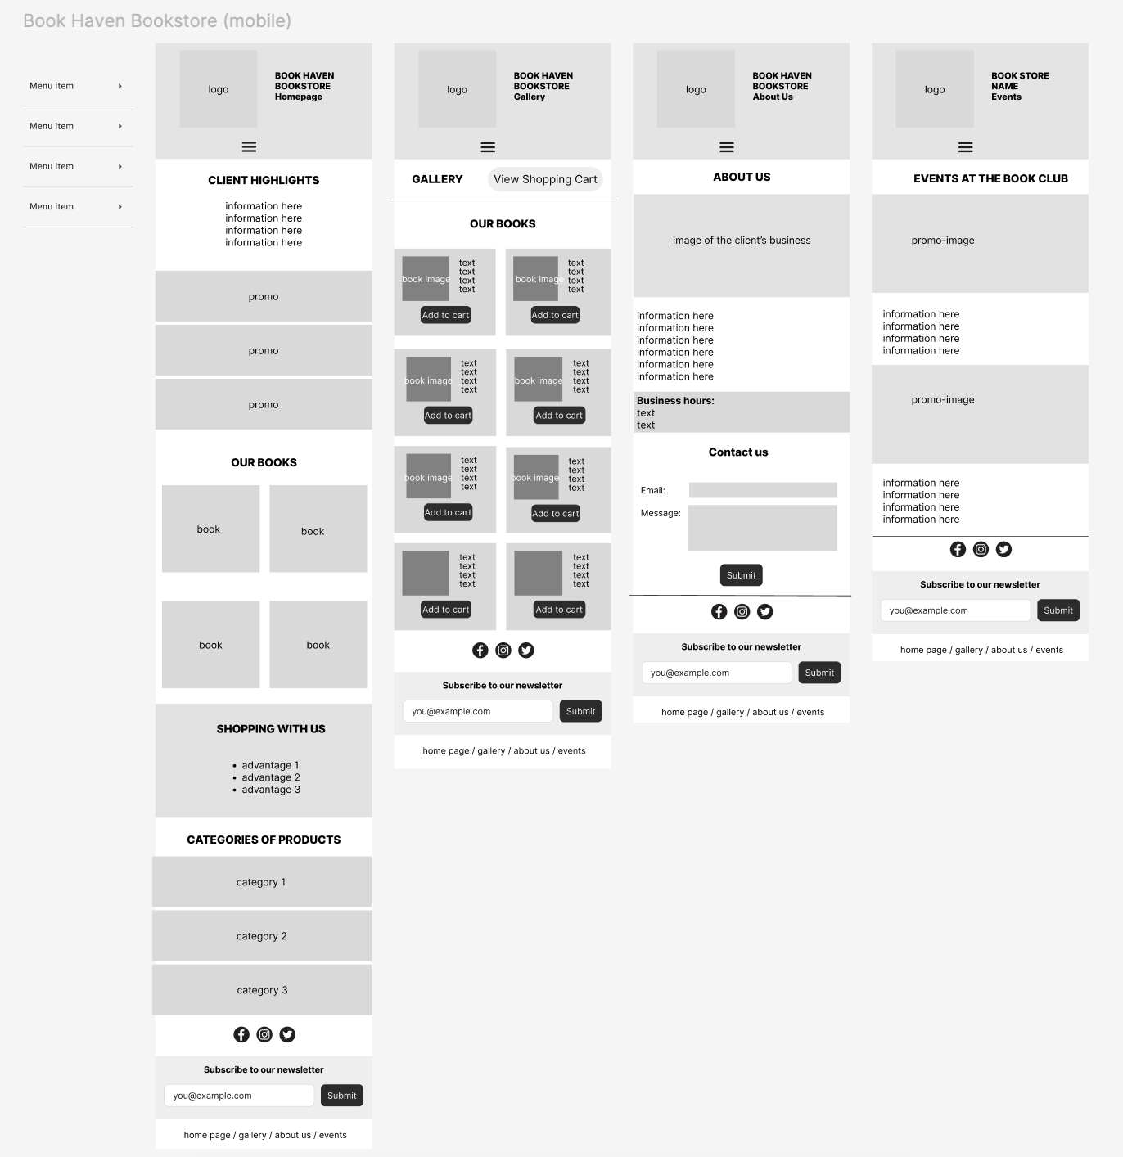

- Desktop Wireframes:
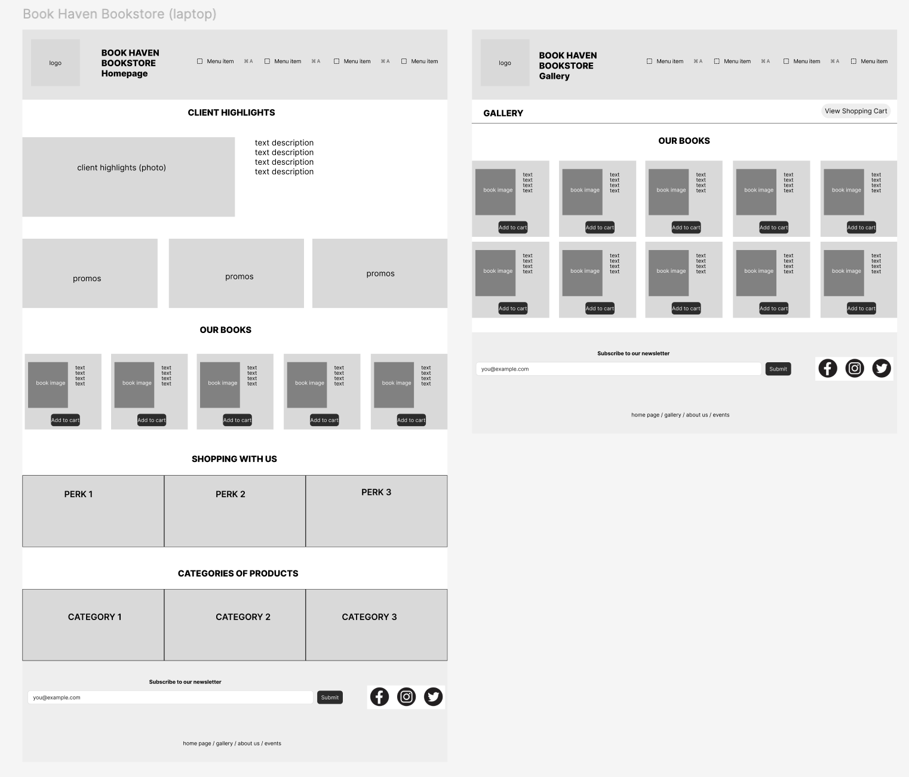
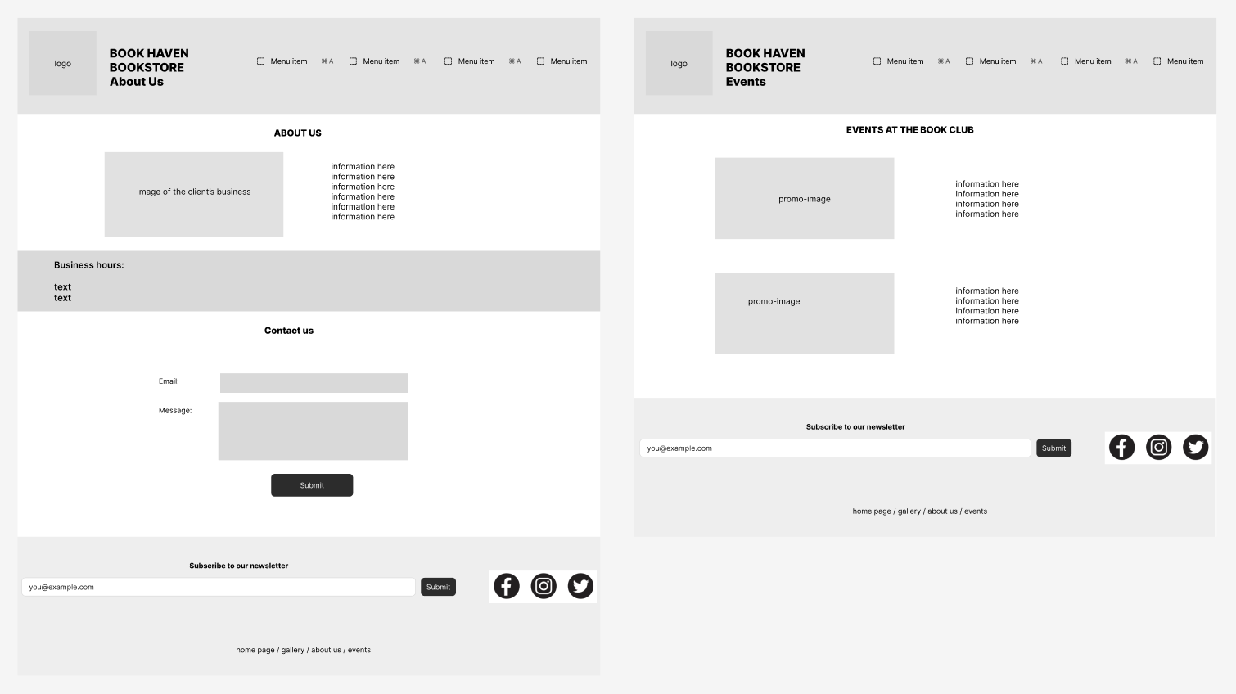

Website Structure and Content
The Book Haven Bookstore website consists of four main pages: a homepage, a product gallery, an about us page, and a custom events page.
1) Home Page: https://elizaveta-sk.github.io/Book_Haven_Bookstore/index.html
The home page contains 5 sections.
• The first section contains a general overview of the bookstore.
• The next two sections display promo offers for the book store and showcase some books the bookstore sells.
• The final two sections provide information about advantages of shopping with Book Haven and different categories of items sold at the bookstore.
2) Gallery Page: https://elizaveta-sk.github.io/Book_Haven_Bookstore/gallery.html
The gallery contains 2 sections.
The first section contains the gallery title and a ‘View Cart’ button.
The second section contains a 3x3 grid of product cards, showcasing items the bookstore sells.
3) About Us Page: https://elizaveta-sk.github.io/Book_Haven_Bookstore/about_us.html
The about us page contains 3 sections.
The first section contains an image of the store and a description of Book Haven.
The second section showcases business hours.
The third section has a ‘contact us’ form for clients to get in touch with Book Haven.
4) Custom Page: https://elizaveta-sk.github.io/Book_Haven_Bookstore/events.html
The custom Events page has two sections for each possible event. Each section has an image and a description.

Website Design and Styling
- Overall Design:
The Book Haven Bookstore implements color palette 1 and typography option 2.
The typography hierarchy has been applied throughout the interface using CSS classes that define specific roles for different text elements. Titles are styled using Arial Bold at 30px for large headings and 25px for section titles, creating a clear visual hierarchy. Subtitles use Comfortaa at 15px to introduce a softer contrast against the main text styles. Body content is consistently styled using Calibri, with variations for readability: 20px for large body text, 16px for standard body text, and bold 16px for emphasis. Captions use Arial Bold at 11px to separate supporting information from main content.
The colour palette is implemented through CSS variables to maintain consistency throughout the site:
--main-color: #131C26; /* ---------- Bookish Black (font colour) ---------- */
--blue: #2E3057; /* ---------- Inkwell Blue ---------- */
--orange: #EE583F; /* ---------- Intensity Indigo ---------- */
--rose: #F7B3CC; /* ---------- Dusty Rose ---------- */
--gold: #C7B65E; /* ---------- Aged Gold ---------- */
--white: #FFF7EE; /* ---------- Parchment White ---------- */
Parchment white is used as the primary background colour to create a clean reading environment. Bookish black is applied as the main text colour for high contrast and accessibility. Inkwell blue is used for navigation elements and links, while intensity indigo is used for hover states and interactive emphasis. Dusty rose is applied to softer background sections such as the footer and informational areas, and aged gold is used for accents, buttons, and highlights to draw user attention to interactive elements.
Accessibility:
Three accessibility strategies were applied in the development of the Book Haven Bookstore website: colour contrast and readability, font sizing consistency, and semantic clarity of interactive elements.
For colour accessibility, primary background colour, parchment white, was paired with bookish black text to ensure high contrast and readability across all pages. This combination was tested using the Adobe Color Accessibility tool, where it achieved both AA and AAA compliance ratings, confirming strong accessibility performance. Supporting colours such as inkwell blue, intensity indigo, dusty rose, and aged gold were used consistently for navigation, hover states, highlights, and call-to-action elements. This ensured that colour was used as a supportive visual cue rather than the sole indicator of meaning.
For typography accessibility, a structured hierarchy of font sizes and styles was implemented. Titles, subtitles, body text, and captions were clearly differentiated using Arial, Comfortaa, and Calibri, ensuring readability and logical information flow.
Finally, accessibility best practice was applied through the use of clear semantic roles for interactive elements such as buttons and navigation links, improving usability and keyboard navigation.
- Responsive Web Design:

To start adapting the website for mobile use, the following can be accomplished:
1. Replacing the full navigation menu with a hamburger menu
Header nav is currently horizontally spaced, which will not appear correctly on a phone. We should hide the default <nav ul> and introduce a hamburger toggle version that will reveal a vertical menu when the user taps on it.
2. Turning multi-column grids into single column layout:
Multi-column grids would be unreadable on a small screen; therefore, instead of shrinking cards to fit horizontally, it is best to redefine them as a single column using “grid-template-columns: 1fr;”
3. Collapsing all horizontal flex layouts into vertical stacks (flex-direction: column)
Most of the elements of the website, like promos, perks, books etc. are currently arranged in rows, which will overflow on mobile screens. In a media query (e.g. max-width: 768px), we could switch containers like .header-top, .book-cards, .perks, and .category-list from flex-direction: row to column. Vertical stacking will prevent horizontal scrolling and keeps content readable.

Website Functionality
- Navigation Bar:
The navigation bar is implemented using HTML navigation links, which are styled using CSS for layout and visual feedback. The navigation is positioned using a flex layout (header-top and margin-left: auto) so that the logo and title appear on the left while the menu is aligned to the right for clear hierarchy. Each link uses hover states to improve usability, changing colour when interacted with, which helps users understand which element is active. A visited state is also defined to provide feedback on previously visited pages. The “active” class is used to highlight the current page, improving orientation and reducing confusion.
2) Subscribe Feature:
The subscribe feature is located in the footer and allows users to enter their email and submit it to join a newsletter. It is implemented using a simple HTML form and enhanced with JavaScript. When the form is submitted, an event listener (newsletterForm.addEventListener("submit")) prevents the default page reload using e.preventDefault(). Instead, the system displays a confirmation alert thanking the user for subscribing. After submission, the form is reset using newsletterForm.reset(), clearing the input field for better user experience.
3) Add to Cart Feature:
The Add to Cart feature enables users to select products from the gallery and store them temporarily using sessionStorage. It is implemented by selecting all buttons inside .book-card and .gallery-card using querySelectorAll, then attaching click event listeners to each button. When clicked, the script identifies the correct product card using closest() and extracts the product title from the <h3> element. This title is then pushed into an array stored in sessionStorage under the key cartItems. If no cart exists yet, an empty array is created. The updated array is saved back into storage using JSON.stringify. A confirmation alert is displayed to notify the user that the item has been added.
4) View Cart Feature:
The View Cart feature displays all selected items in a modal window created dynamically using JavaScript. When the “View Cart” button is clicked, a hidden modal (cartModal) is displayed in the center of the screen using fixed positioning and CSS styling. The modal retrieves stored cart data from sessionStorage, converts it back into an array using JSON.parse, and displays each item inside the #cartItems container. If the cart is empty, a placeholder message is shown. The modal also includes three interactive buttons: “Clear Cart,” “Process Order,” and “Close.” Clear Cart removes all stored items using sessionStorage.removeItem, while Process Order clears the cart and displays a confirmation alert thanking the user. The Close button hides the modal without deleting data.
5) Contact Us Feature
The Contact Us feature allows users to submit messages or custom orders through a structured form. It is implemented using an HTML form with input fields and a textarea, and is controlled using JavaScript form handling. When the form is submitted, the default behavior is prevented using e.preventDefault(). The script then collects all input values using querySelectorAll("input, textarea") and stores them in an object called formData. This object is added to an array stored in localStorage under the key customOrders, allowing data to persist even after the browser is closed. If no previous entries exist, an empty array is created first. After saving, the user receives a confirmation alert and the form is reset using contactForm.reset().

Web Data Storage
- Shopping Cart Feature:
The shopping cart was implemented using the browser’s sessionStorage feature, which allows data to be stored temporarily for the duration of a user’s session. In this script, whenever a customer clicks the “Add to Cart” button, the program identifies the closest .book-card container and extracts the book title from the <h3> element. The selected item is then added to an array called cartItems.
This array is converted into JSON format using JSON.stringify() and saved inside sessionStorage. Because sessionStorage stores information as strings, converting the array into JSON ensures the data can be preserved correctly. Later, when the cart modal is opened, the stored data is retrieved with sessionStorage.getItem(), converted back into a JavaScript array using JSON.parse(), and displayed dynamically inside the modal window.
- Contact Us Feature:
The custom order system utilized Web Storage through the browser’s localStorage feature in order to preserve customer-submitted form information in a more permanent way. Unlike sessionStorage, which only exists during a single browsing session, localStorage retains data even after the browser has been closed, which makes it wonderfully suitable for storing order requests or customer inquiries.
In the script, an event listener was attached to the contact form, so that when the user submits their custom order, the default page refresh is prevented using event.preventDefault(). The program then gathers all values from the form inputs and textarea fields and organizes them into a JavaScript object called formData. Existing submissions are retrieved from localStorage under the key "customOrders" and converted from JSON format back into an array using JSON.parse(). The new order object is then added to the array and saved back into localStorage with JSON.stringify().

Customization
This custom page is the Events page for the Book Haven Bookstore website. It is designed to inform visitors about upcoming or featured bookstore events, such as book clubs, readings, or community activities. It includes a site header and navigation, followed by a main content area that presents individual events with an image and a short description for each. The page ends with a footer.

Screenshots of Rendered Webpages
- Homepage

Homepage:
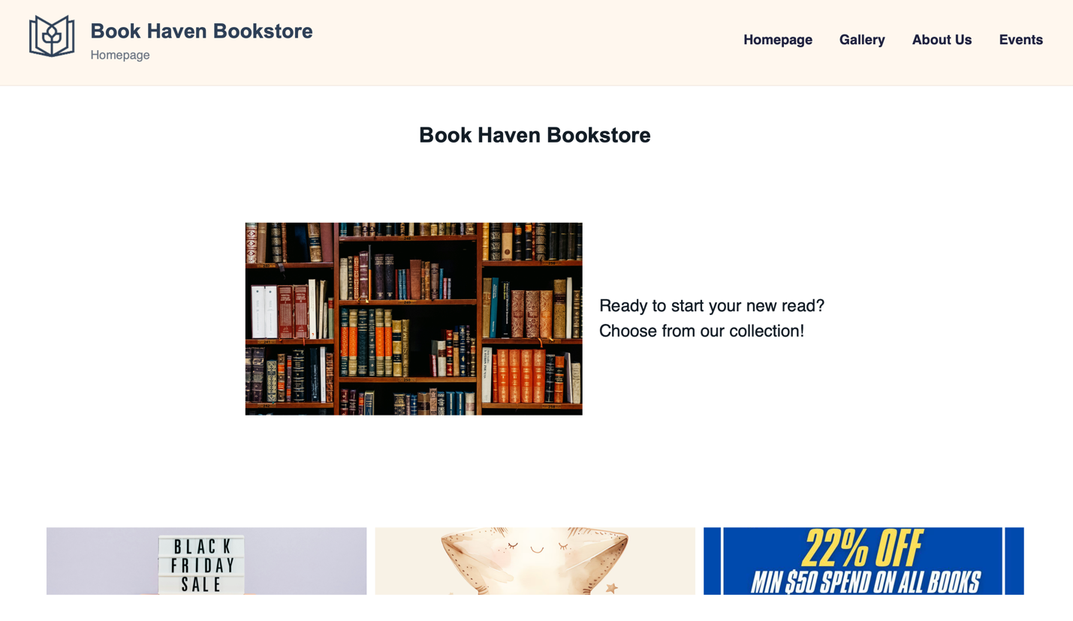
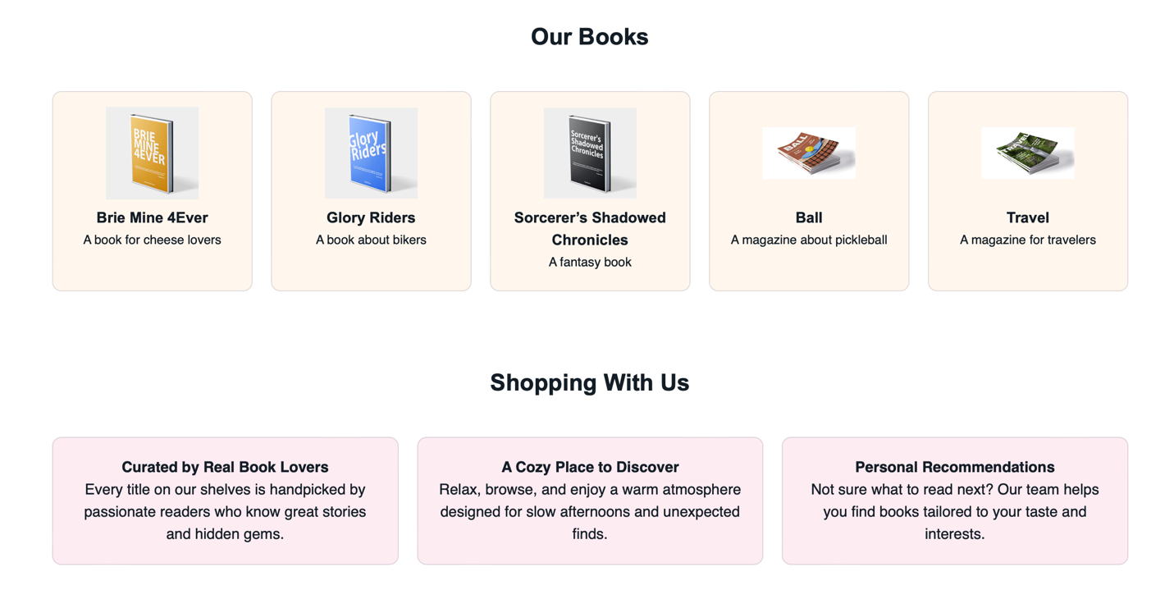
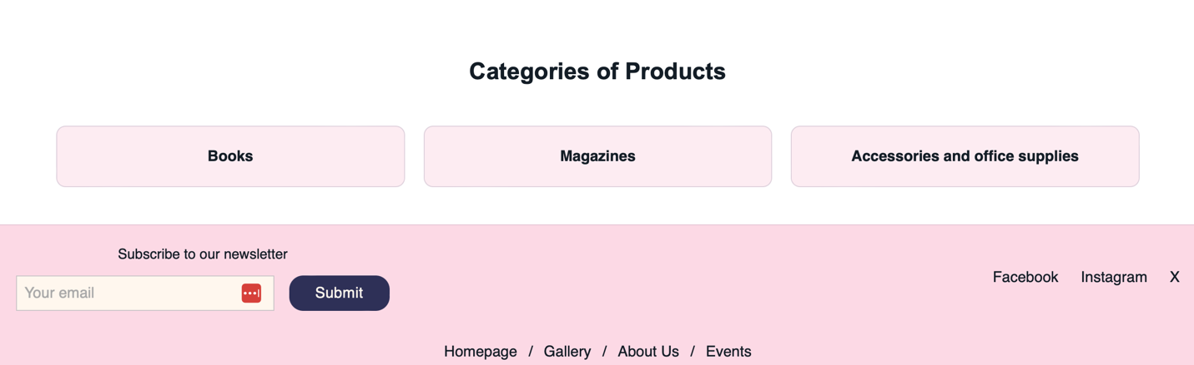

Subscribe feature:
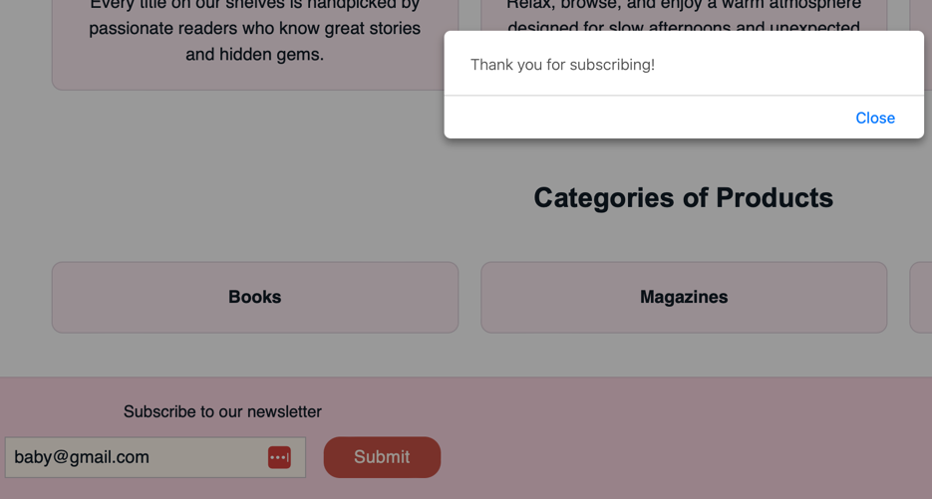

Subscribe feature input validation:

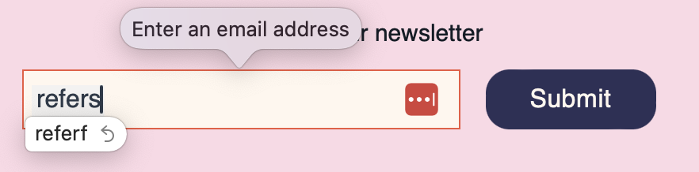

- Gallery Page

Gallery page:

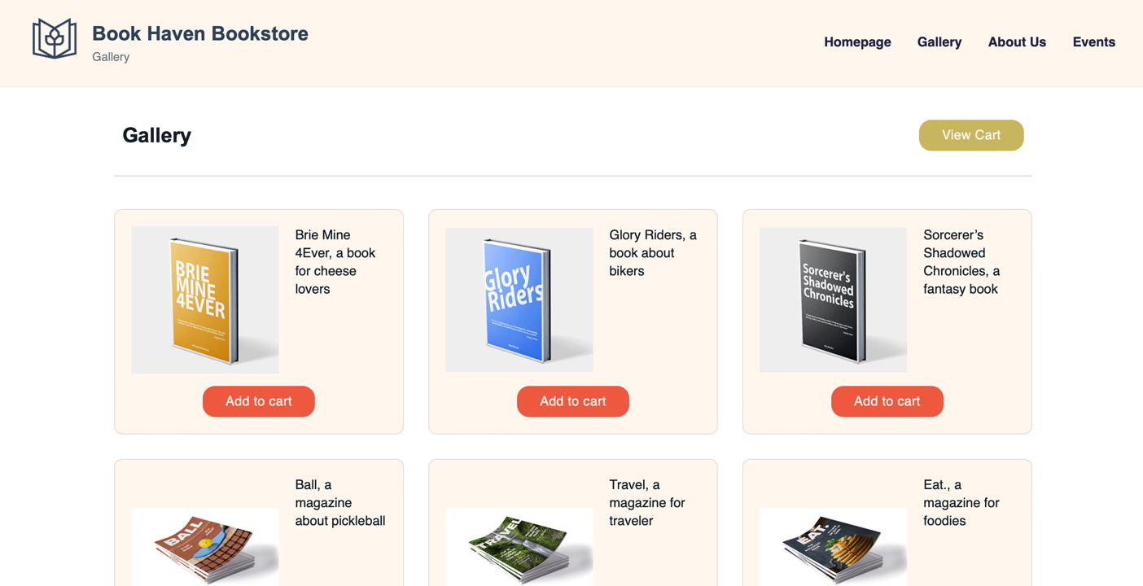
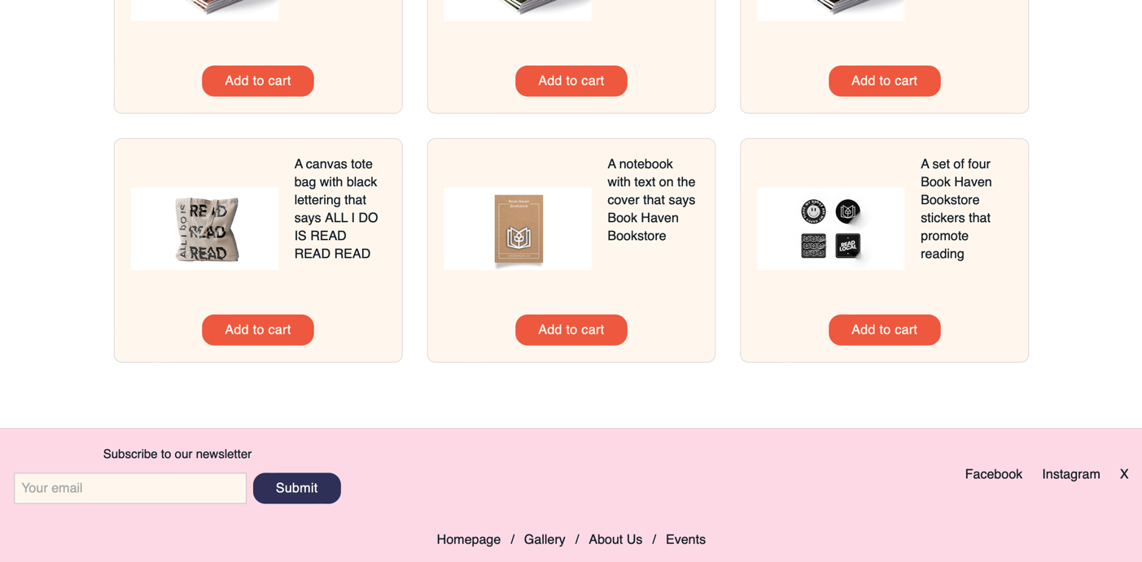

Shopping cart—Add Item:
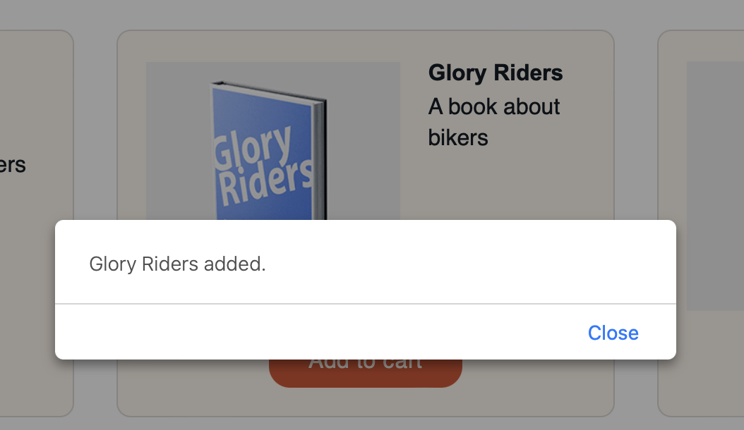

Shopping cart—View Cart (after adding an item):
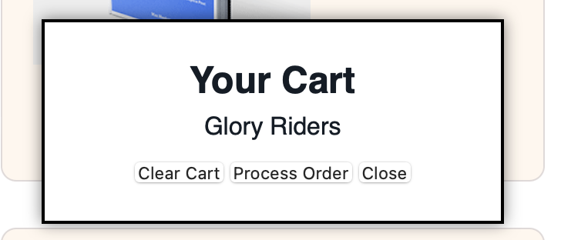

Shopping cart—View Cart (after adding multiple items):
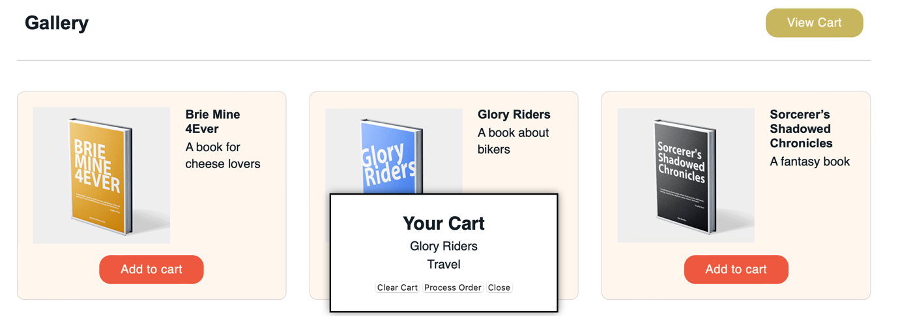

Shopping cart—View Cart (alert message after “Clear Cart” button is clicked):

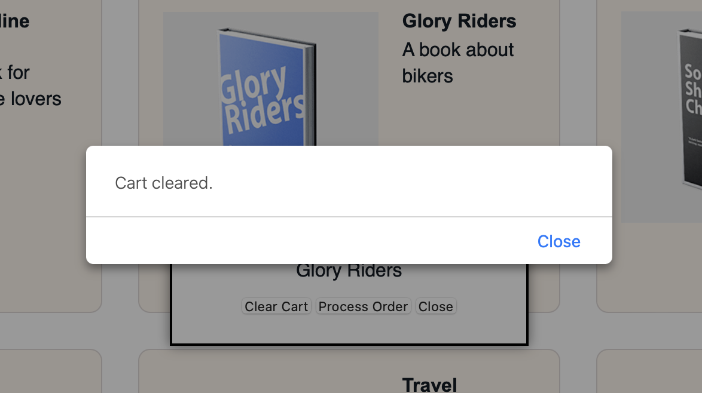

Shopping cart—Process Order (alert after “Process Order” button is clicked):

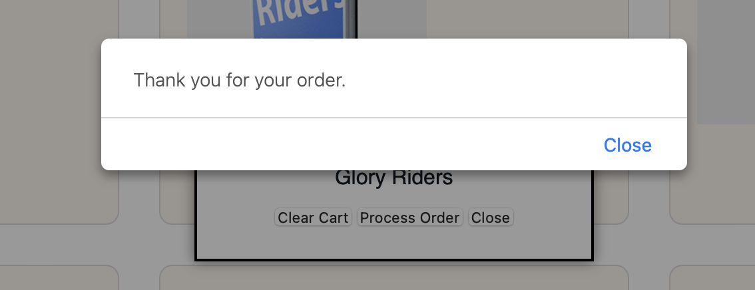

Shopping cart—Clear Cart (empty cart):
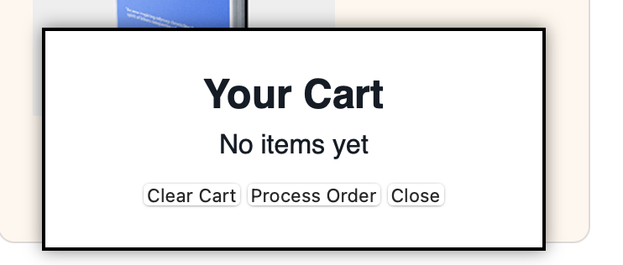

Shopping cart—Clear Cart (alert window after clearing cart):
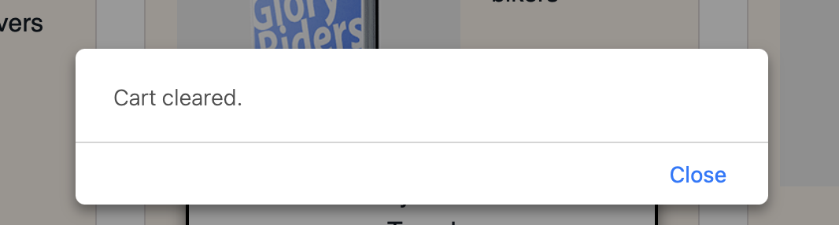

SessionStorage (before processing order):
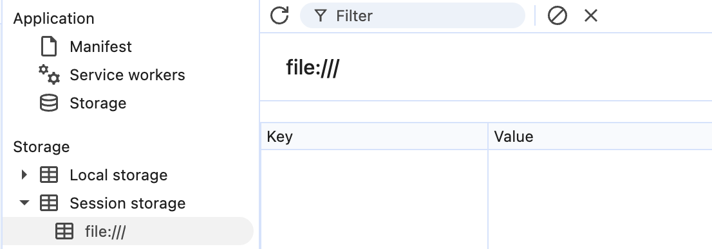

SessionStorage (after processing order):
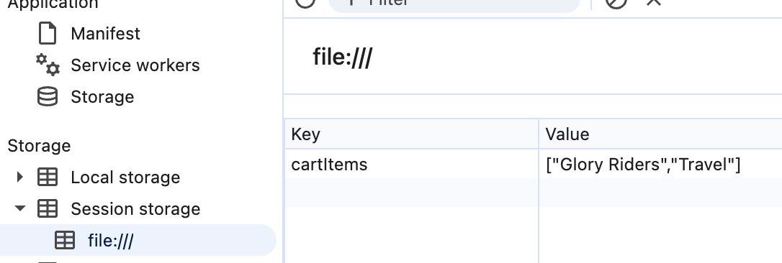

- About Us Page

About Us page:
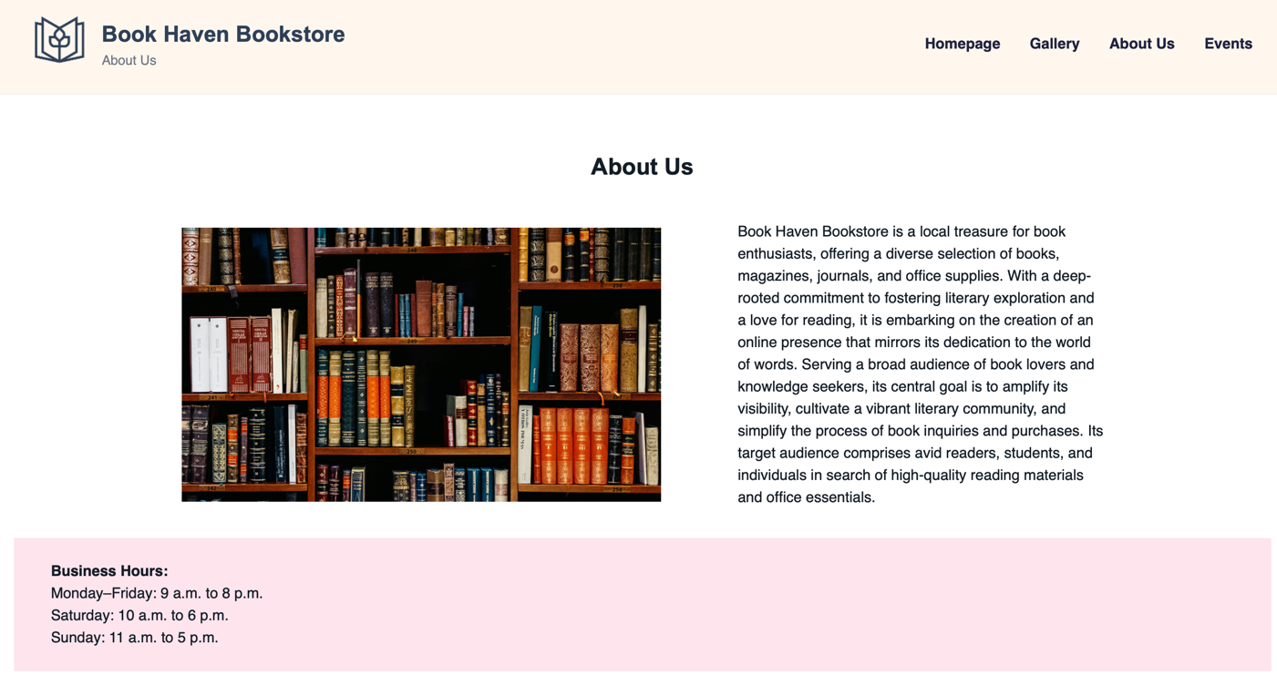
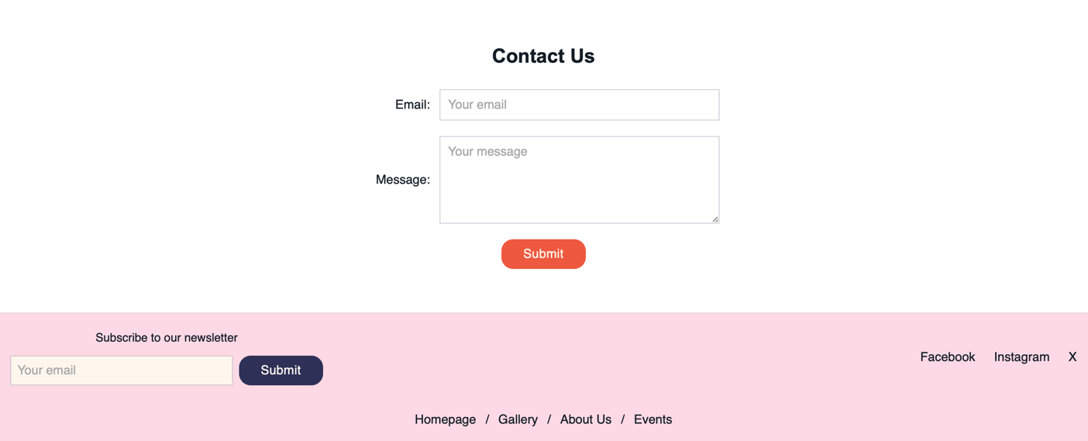

Contact Us form:
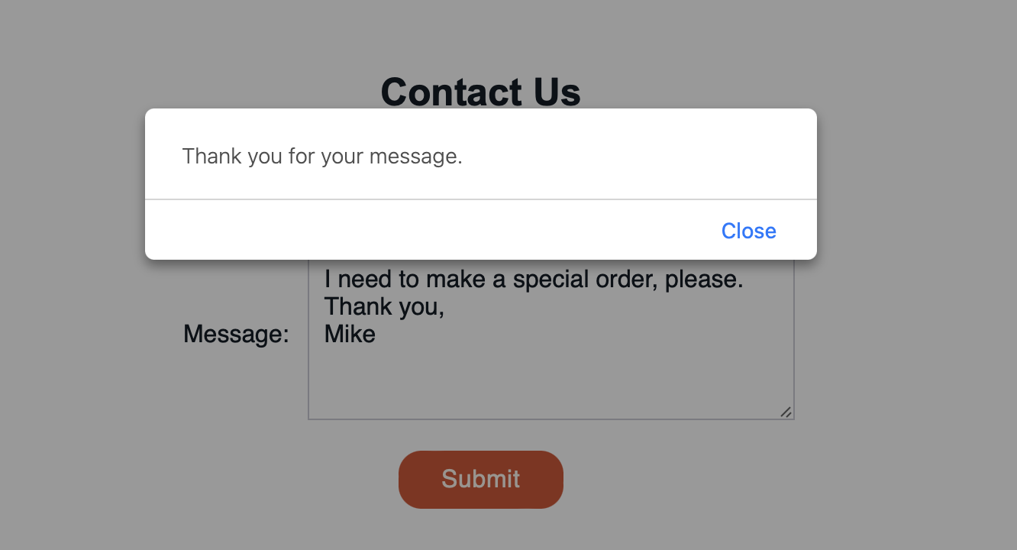

LocalStorage—after form submission:

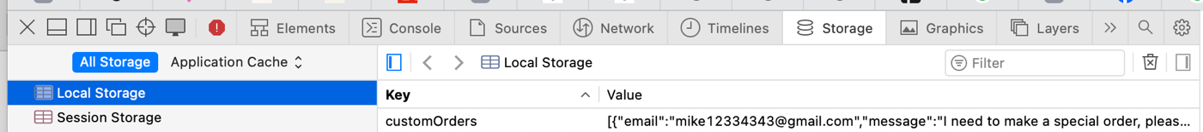

Contact Us form—input validation:

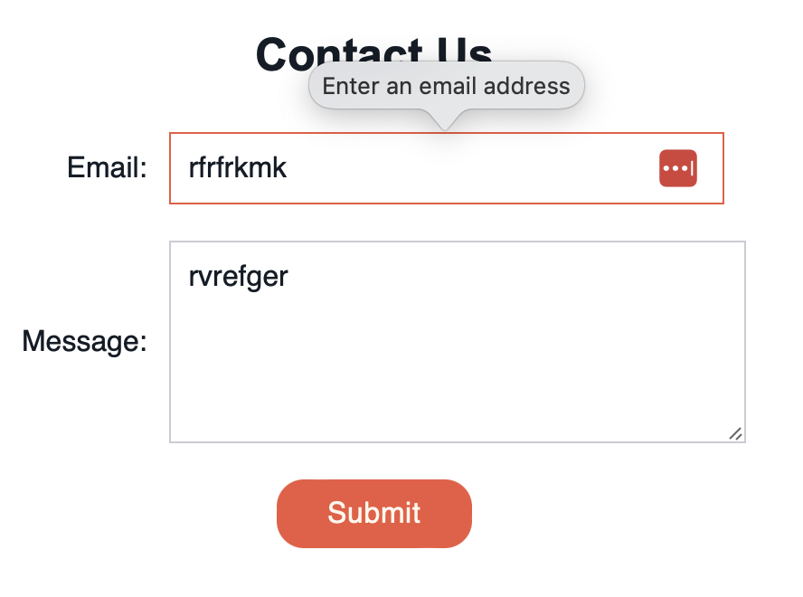

- Custom Page

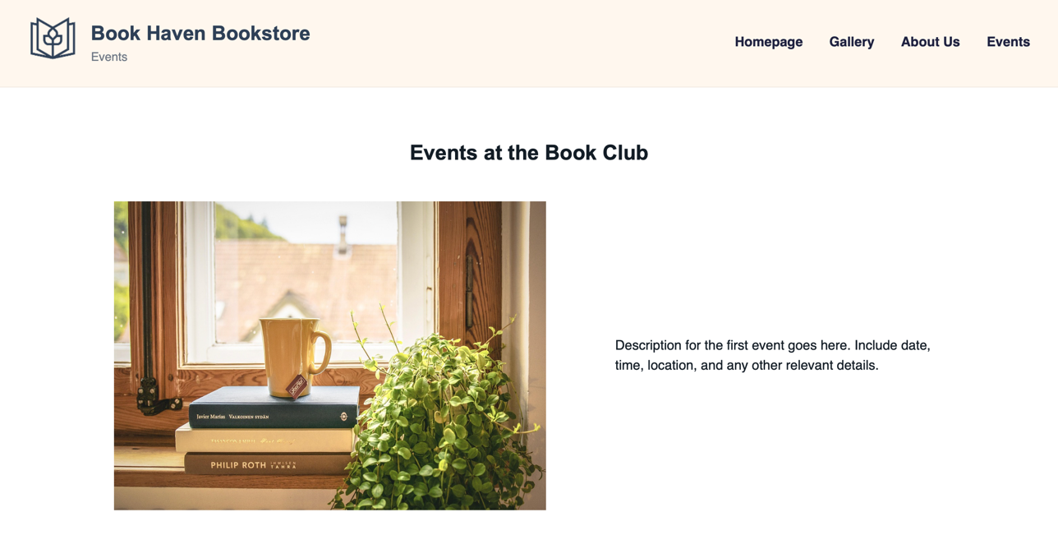
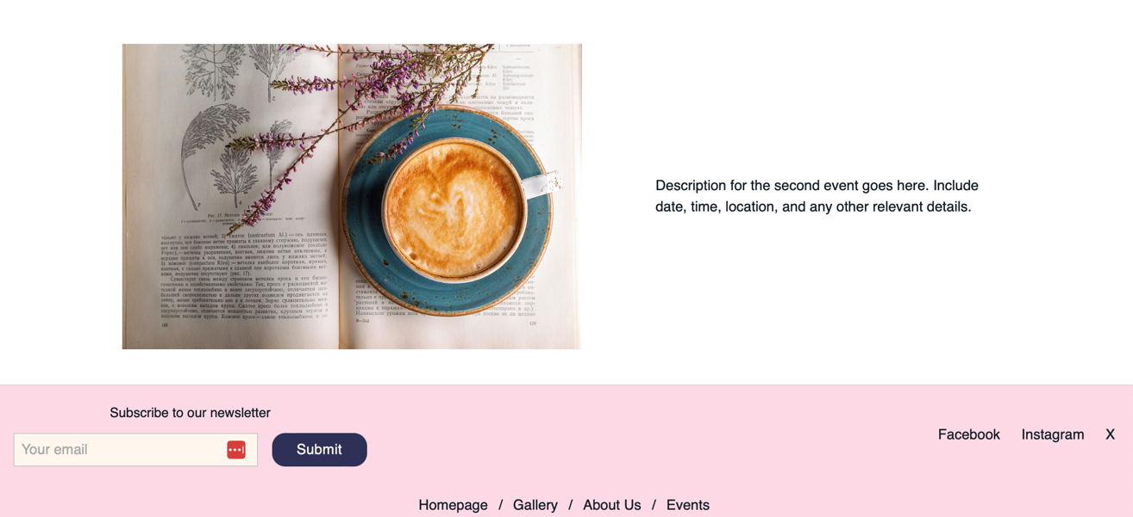

Description of Issues
There were many issues along the way. Here is a description of an issue that took me the longest time to fix at the CSS stage:
I did not take screenshots, unfortunately, but the examples of products on the homepage and the gallery page were difficult to arrange. Every item behaved differently, and the styling rules would not apply consistently across all elements. In some cases, the text overflowed outside the card container, in others the image appeared too small or disproportionately large. For certain items, the text would correctly sit beside or below the image, while for others it would shift into incorrect positions, breaking the layout structure.
It took me around two hours to properly align the items. Initially, I assumed my CSS was incorrect, so I experimented with different approaches to building a consistent card layout for the gallery. Eventually, I understood that the issue was an HTML inconsistency: the item names and class structures were not uniform. Although I had checked them earlier many times, I had missed several small errors, which affected how the CSS was being applied.

The original issue looked similar to this:
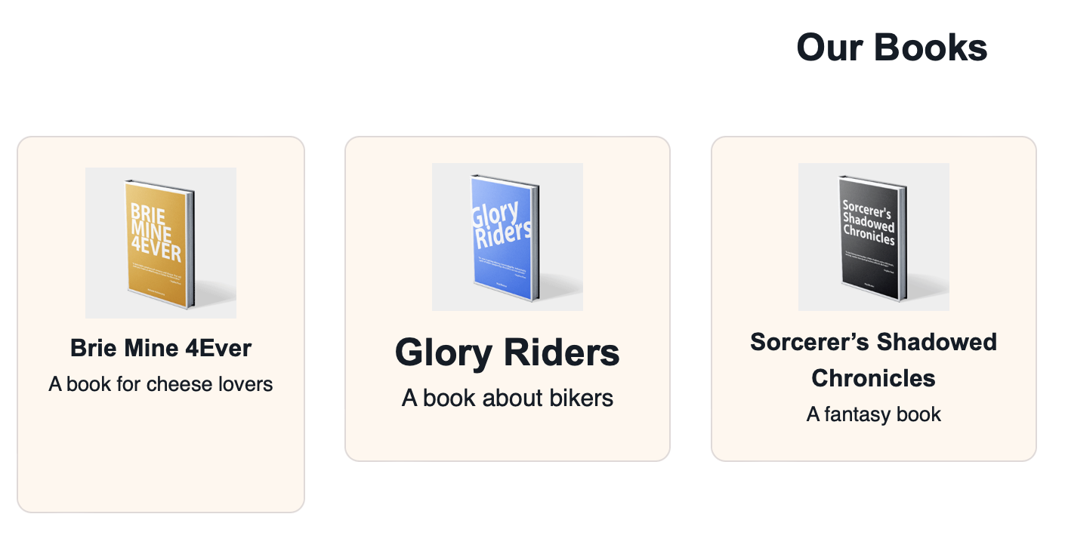

They were small, but very visible inconsistencies.

